CSCE 5320 - Scientific Data Visualization

Project 1 Report: Social Media Sentiment Analysis and Visualization
Team Members:
Lohitha Konidena
Sai Sathvika Potluri
Sai Karthik Nimmagadda
1. Introduction
Project Title: Social Media Sentiment Dashboard: A Comparative Visualization of Twitter and News Sentiments
Domain: Data Visualization and Social Media Trends
Objective:
A study analyses variability in public opinions which exists between Twitter's social media platform and standard news headlines. The analysis between sentiment trends was possible through the use of Power BI and Python which created visualizations that revealed information about emotional tone together with platform biases along with sentiment alterations throughout time. This document details the procedure for preparing data along with visual development phases and analysis findings.
2. Problem Statement:
The analysis of sentiment transformation between Twitter platforms and traditional news media proves useful for studying public sentiments together with media tonal changes. This research investigates the temporal differences in sentiment distribution between Twitter and News platforms while exploring the detectable data patterns.
3. Methodology:
Workflow Diagram:
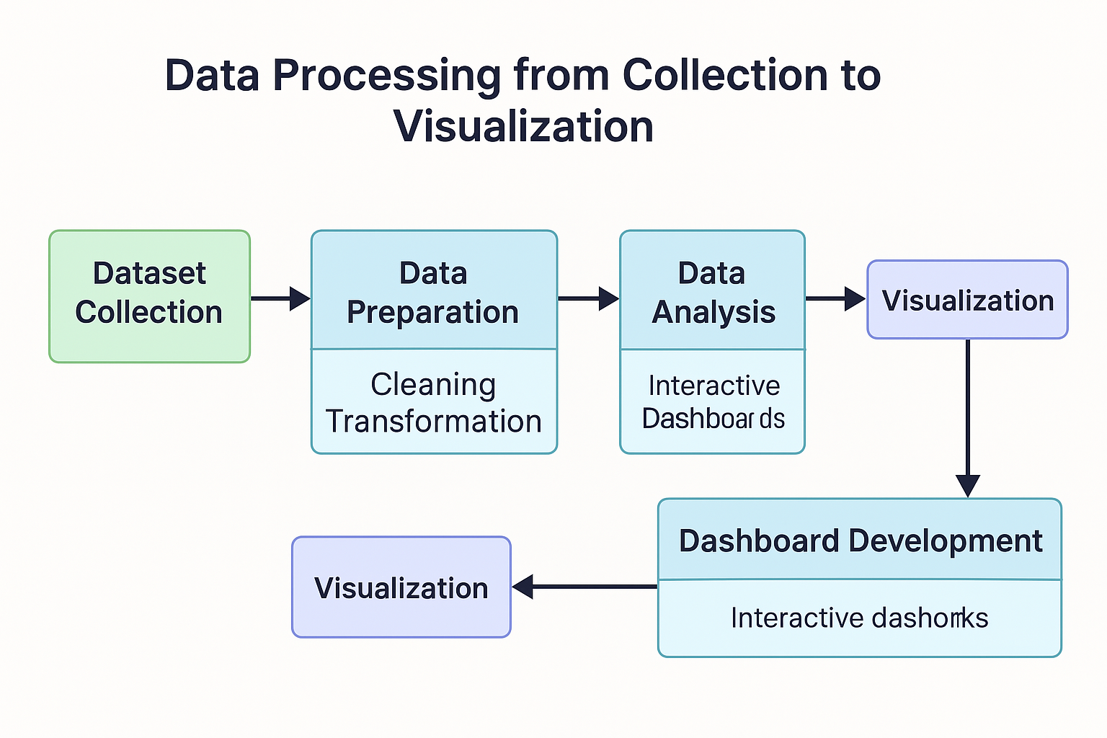
- Data Collection (Twitter + News)
- Data Cleaning & Preprocessing
- Sentiment Mapping (Binary Classification)
- Merging and Transformation
- Dashboard Development (Power BI + Python)
- Visualization and Insight Generation
Data Cleaning and Integration:
- Null and duplicate values were removed from both datasets.
- Column headers were renamed for consistency.
- A unified column structure was created to merge both sources.
Sentiment Mapping:
- Twitter sentiment labels (0/4) were mapped to “Negative” and “Positive”.
- News headlines were analyzed using rule-based mapping into binary sentiments.
Exploratory Data Analysis (EDA):
- Distribution of sentiment across platforms and over time.
- Temporal pattern analysis using line charts and stacked visuals.
Visualization Strategy:
- Power BI was used for dashboard and filterable interactive visuals.
- Python (Seaborn/Matplotlib) created more flexible custom plots.
- Text analysis performed using WordCloud to understand context.
Insight Extraction:
- Used counts, groupings, and time-based rollups to compare trends.
- Filtered by Source and Sentiment in various visual forms.
4. Data Abstraction:
Dataset Descriptions:
Sentiment140 Dataset (Twitter Data)
Source: Kaggle (https://www.kaggle.com/datasets/kazanova/sentiment140 )
Size: 1.6 million tweets
Attributes: target, id, date, query, user, text
Label Meaning:
0 = Negative sentiment
4 = Positive sentiment
The model training process begins with this dataset and it also enables the creation of time-based sentiment visualization for Twitter data.
Custom News Headlines Dataset
Source: Public/open-access dataset containing headline and date fields
Size: ~15,000 headlines
Attributes: headline, date
Usage of Datasets:
- The Sentiment140 (Twitter) dataset served to evaluate public opinions within Twitter posts. The existing sentiment labels in this dataset included negative and positive as well as a numeric rating range from zero to four.
- The News Dataset served the purpose of detecting sentiment direction within news headlines. Person-made instructions classified textual data points into either the Positive or Negative category.
- A combined dataset resulted from cleaning and merging two datasets which received analysis through Power BI and Python visualizations.
Data Transformation:
- Removed nulls and duplicates
- Mapped sentiment values (0/4 → Negative/Positive)
- Parsed and unified dates
- The datasets were appended together for joint evaluation purposes.
5. Task Abstraction
Target:
- Analyzing the emotional divergence between information contained in News media and Twitter platforms constitutes a major objective.
- The system should identify emotional shifts that occur over time periods.
- Expose any trends in sentiment bias patterns as well as intensity fluctuations.
Actions:
- The analysis uses three categories of grouping and aggregation including source, sentiment, and date.
- The analysis employs line together with area charts to study temporal patterns.
- Keyword extraction using WordCloud.
6. Implementation Using Tools
Tools Used:
- Power BI Desktop
- Python (Jupyter, Matplotlib, Seaborn, WordCloud)
Implementation Steps:
- Loaded datasets in Power BI via Power Query Editor
- Used Python to preprocess data and generate visualizations
- Built bar, donut, line, and area charts in Power BI
- Created heatmaps, grouped bar plots, and pie charts in Python
How Visualizations Help:
- Understand sentiment volume per platform
- Track change in sentiment over months
- Compare sentiment intensities visually
- Surface contextual clues through WordCloud
- Results and Analysis
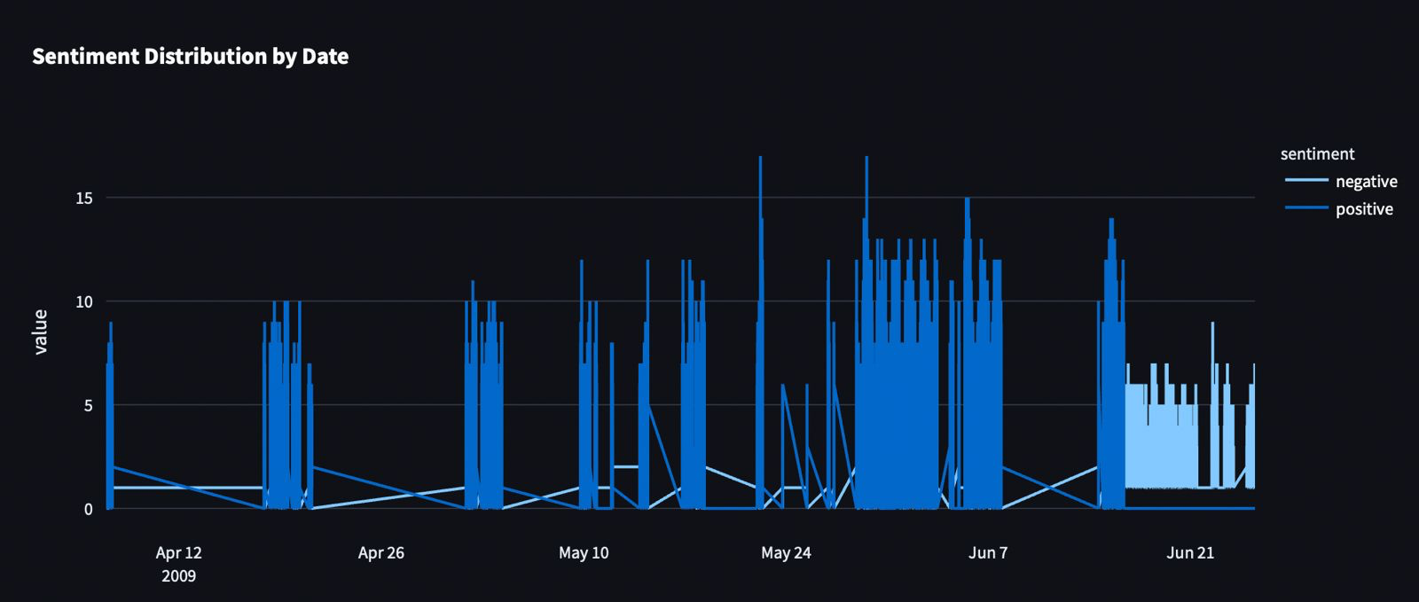
Figure 1: Sentiment Distribution by Date
The line chart monitors Twitter sentiment changes across time in the dataset. Public response to different types of events is shown through high and low points in the chart.
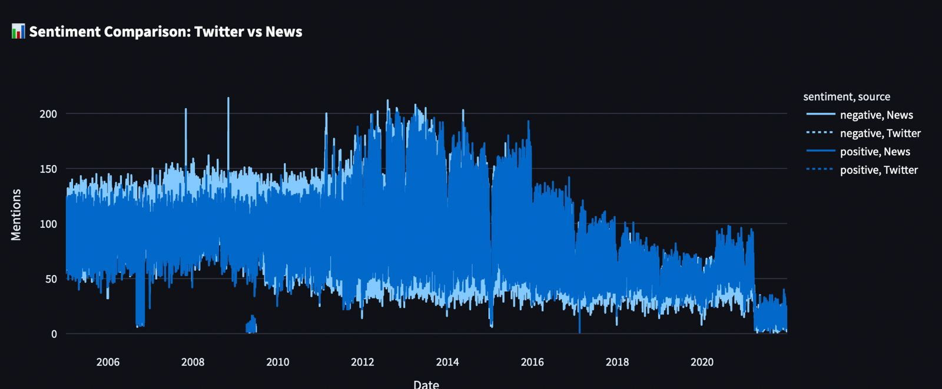
Figure 2: Sentiment Comparison – Twitter vs News
The comparative area chart establishes divergent sentiment pattern changes between News and Twitter from 2003 through 2020. Twitter exhibits higher volatility since News data maintains a steady negative trend.
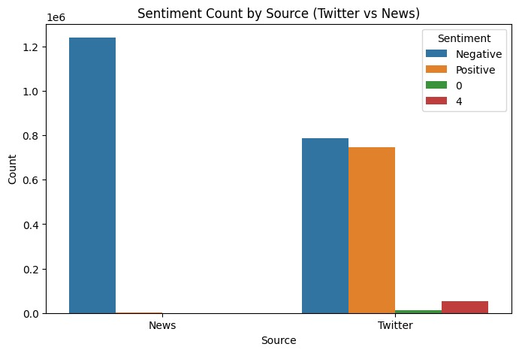
Figure 3: Sentiment Count by Source
The two sources show their sentiment frequency results through this grouped bar chart. The news presents primarily negative content while Twitter users demonstrate more positive-bias content distribution.
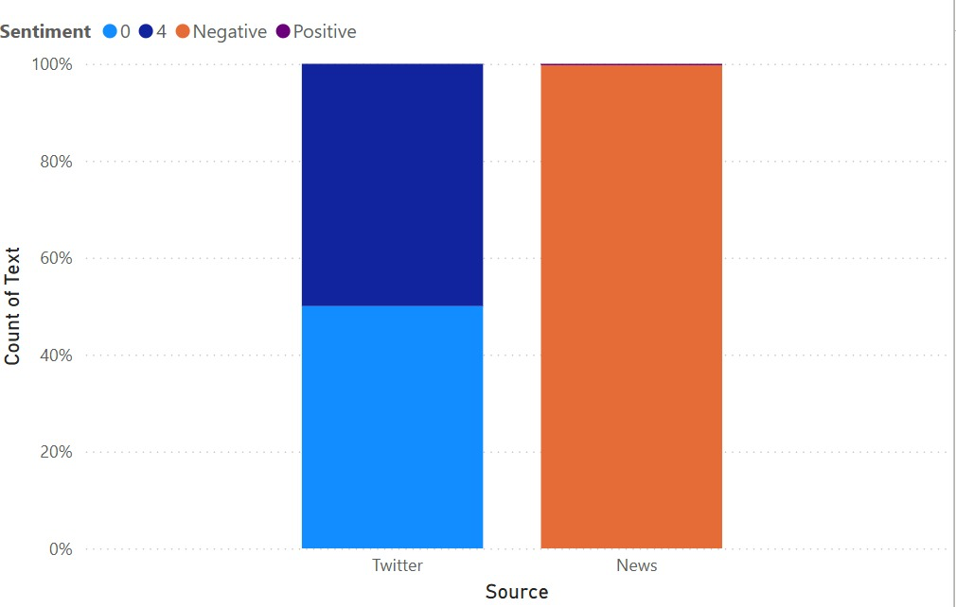
Figure 4: Proportional Sentiment per Source
Each source displays its sentiment proportions using 100% stacked column chart visualization. Twitter presents sentiment distribution that extends beyond negative and positive while News primarily consists of negative sentiment only.
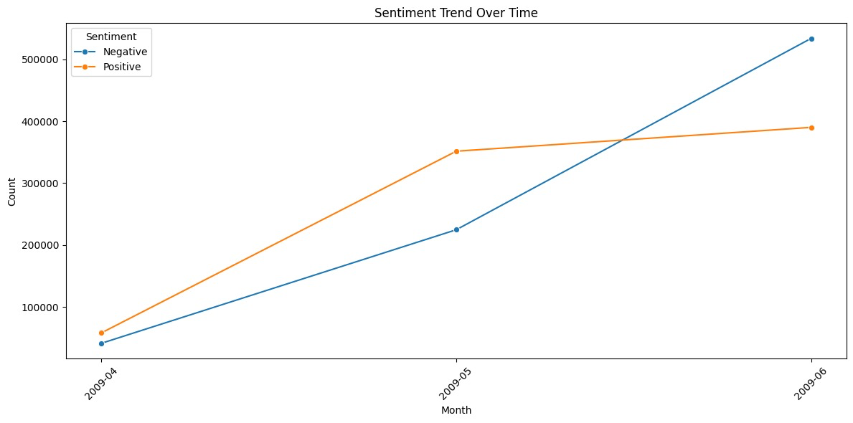
Figure 5: Sentiment Trend Over Time
The monthly trend line demonstrates that social media activity keeps growing in positive and negative sentiments due to increasing polarized engagement throughout the month.
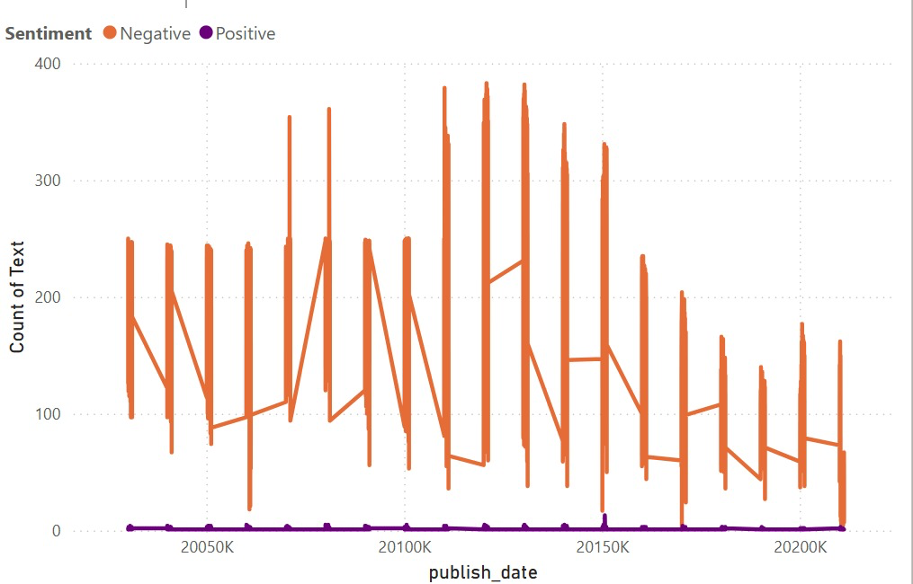
Figure 6: Publish Date vs Sentiment Line Chart
The representation shows how news headlines display emotional shifts throughout successive years. Throughout most of the timeline negative sentiment consistently stands out over other sentiments.
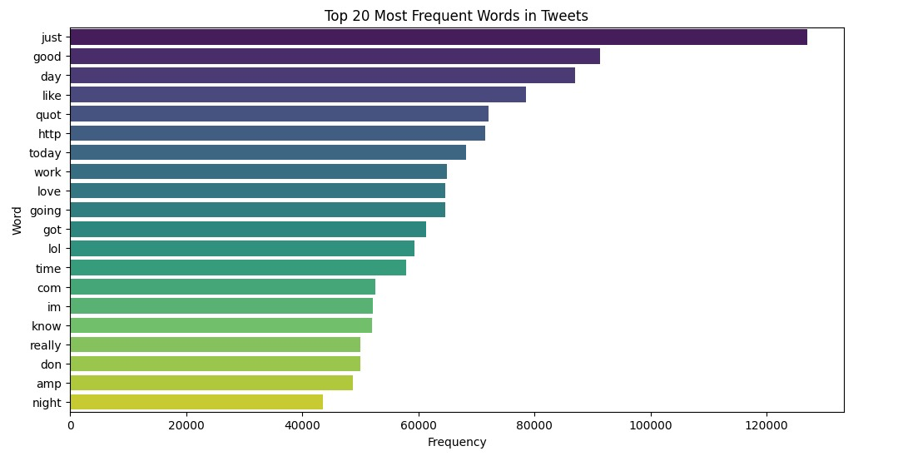
Figure 7: Top 20 Frequent Words in Tweets
This horizontal bar chart identifies the most frequently used words in tweets. Words like “just,” “good,” and “like” indicate common emotional expressions among users.

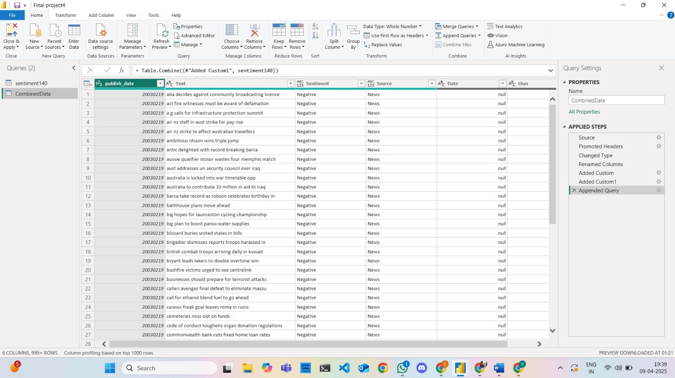
Figure 8: Combined Dataset View in Power BI
The successful fusion of News and Twitter data appears through visual screenshots from Power BI. The steps for transformation and mapping become visible within the applied steps pane.

8. Work Management
Team Members:
Lohitha Konidena – Visualizations & Power BI Logic
Sai Sathvika Potluri – Data Cleaning & Integration
Sai Karthik Nimmagadda – Python Visualizations & Report Writing
Implementation Status:
- Data cleaning, transformation, and visualization complete
- Report and presentation materials drafted
9. Next Steps for Project 2
- Integrate additional platforms (Reddit, YouTube)
- Fully interactive dashboards should be constructed using either D3.js or Plotly.
- The process of sentiment detection needs improvement through machine learning classification techniques.
- HTML/CSS + JS code will be used to design and deploy the dashboard web page.
- The use of animated visuals for tracking time-based trends should be examined.

